**DevOps project code modification and automatic CI and CD deployment**

1. In the last DevOps Starter app created. After the release is succeeded, go to “repository”

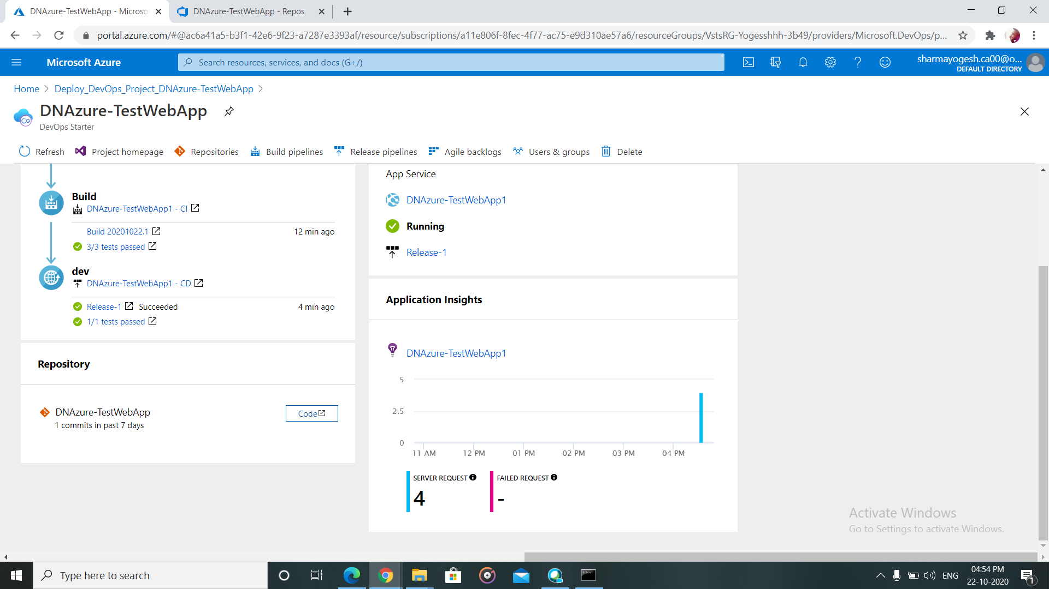

2) Open index.cshtml in application>SampleWebApplication>>Views>Home>Index.cshtml.

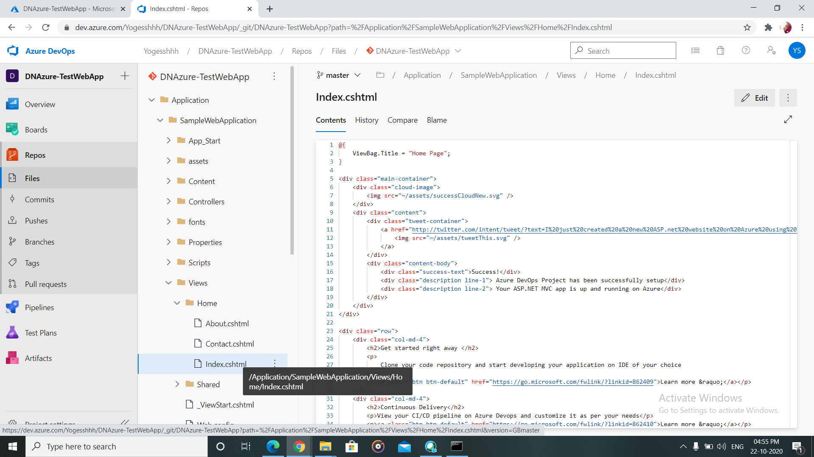

1. Do some changes in this file to see on the page and “commit”.

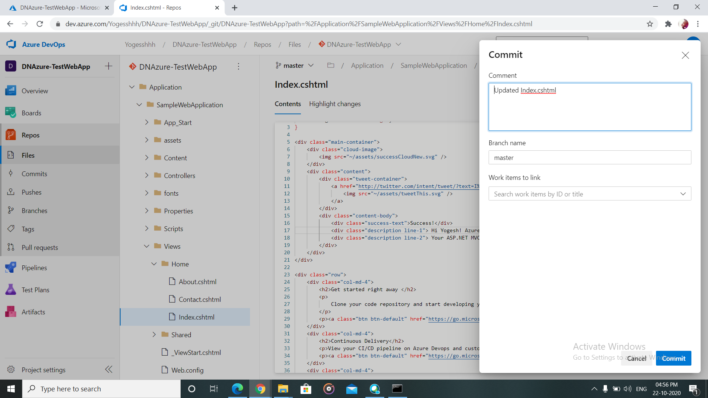

1. Check the release for successful commit and then browse the web app again. The changes will be reflected there.